**COMSATS University Islamabad,   
Abbottabad Campus**

**SOFTWARE DESIGN DESCRIPTION   
(SDD DOCUMENT)**

**for**

**FurnishARt (An AR-Based Furniture Store)**  
Version 1.0

***By***

1. **Muhammad Umer CIIT/SP21-BCS-016/ATD**
2. **Muhammad Noman CIIT/SP21-BCS-014/ATD**
3. **Hafiz Talha Nazir CIIT/SP21-BCS-007/ATD**

***Supervisor***Mam Bushra Mushtaq

***Bachelor of Science in Computer Science (2021-2025)***

**Table of Contents**

**Revision History 3**

**1.** **Introduction 5**

**2.** **Design Methodology and software process model 5**

**3.** **System Overview 5**

3.1 Architectural Design 5

3.2 Process Flow/Representation 5

**4.** **Design Models [along with descriptions] 5**

**5.** **Data Design 6**

5.1 Data Dictionary 6

**6.** **Algorithm & Implementation 6**

**7.** **Software Requirements Traceability Matrix 6**

**8.** **Human Interface Design 7**

8.1 Screen Images 7

8.2 Screen Objects and Actions 7

**9.** **Appendix I 7**

**Revision History**

|  |  |  |  |
| --- | --- | --- | --- |
| **Name** | **Date** | **Reason for changes** | **Version** |
|  |  |  |  |
|  |  |  |  |

**Application Evaluation History**

|  |  |
| --- | --- |
| **Comments (by committee)**  **\*include the ones given at scope time both in doc and presentation** | **Action Taken** |
|  |  |
|  |  |

**Supervised by**

**<Supervisor’s Name>**

Signature______________

## Introduction

The project aims to develop an augmented reality (AR)-based Online Furniture Store website that enhances the online shopping experience by allowing customers to visualize and interact with 3D furniture models in their own physical space using their smartphone cameras. This integration of AR technology aims to bridge the gap between online and offline shopping experiences, empowering customers to make informed purchasing decisions. The project covers several key modules including 3D model creation and management, AR preview mode, user authentication, furniture listing, customer reviews management, secure payment processing, and administrative functionalities.

## Design Methodology and Software Process Model

**Design Methodology:** Object-Oriented Programming (OOP)

Object-Oriented Programming (OOP) principles have been chosen for this project. OOP promotes modular, maintainable, and scalable code through concepts like encapsulation, inheritance, and polymorphism. This approach aligns well with the Agile software development methodology, allowing for iterative development and continuous improvement based on user feedback.

**Software Process Model:** Agile

Agile methodology has been selected for this project. Agile is favoured for its flexibility, adaptability, and customer-focused iterative approach. It enables efficient development and integration of AR functionality into the online furniture store by breaking down the project into manageable units (sprints) that deliver tangible value to users after each iteration.

## System Overview:

The AR-based Online Furniture Store integrates augmented reality (AR) technology with e-commerce, enabling users to visualize, interact with, and purchase furniture in a virtual environment. Key modules include:

* **3D Model Creation and Management:** Handles creation, storage, and retrieval of 3D furniture models.
* **Augmented Reality Preview Mode:** Allows users to see furniture in their space using AR.
* **User Authentication and Registration:** Provides secure access for users and administrators.
* **Furniture Listing and Management:** Displays a searchable catalog of furniture items.
* **Customer Reviews Management:** Enables users to review and rate purchased items.
* **Secure Payment Processing:** Ensures safe and reliable online transactions.

## Architectural Diagram:

## Class Diagram

## Use case diagram:

## Sequence Diagram:

## ER Diagram:

## Activity Diagram:

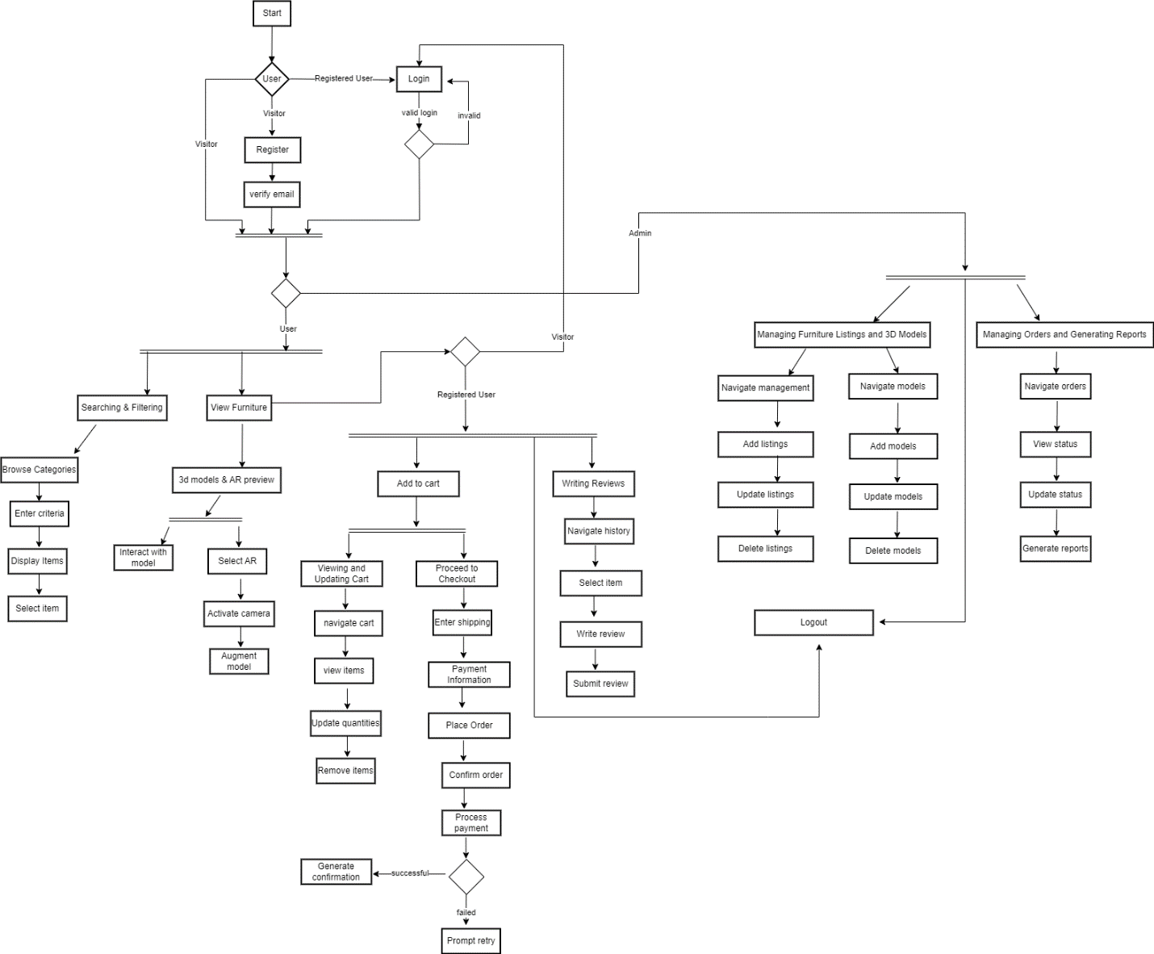

## Human interface design:

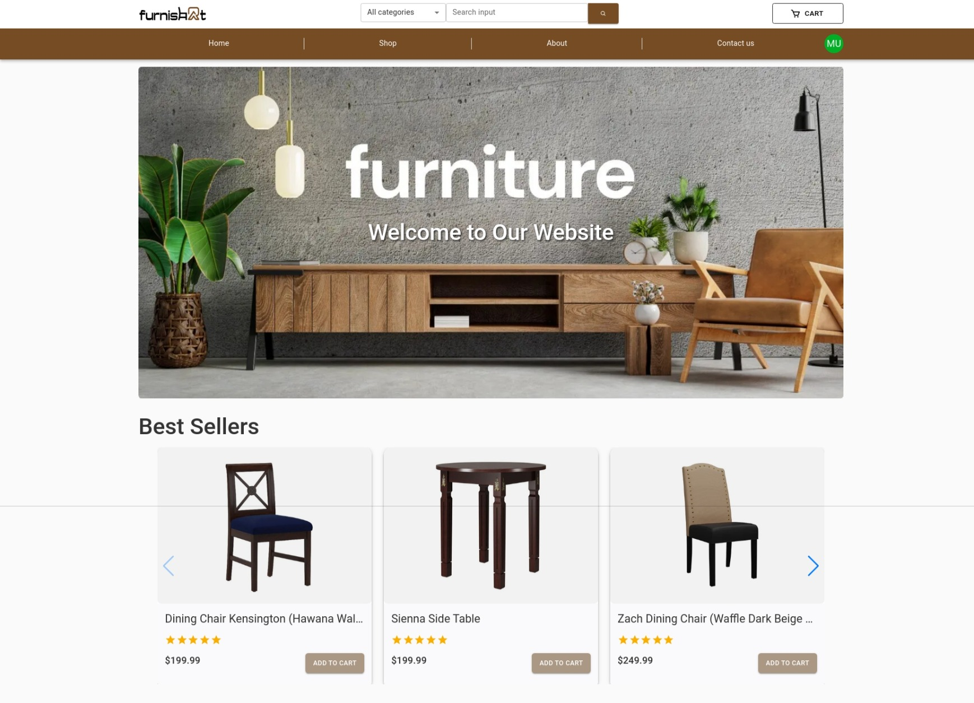

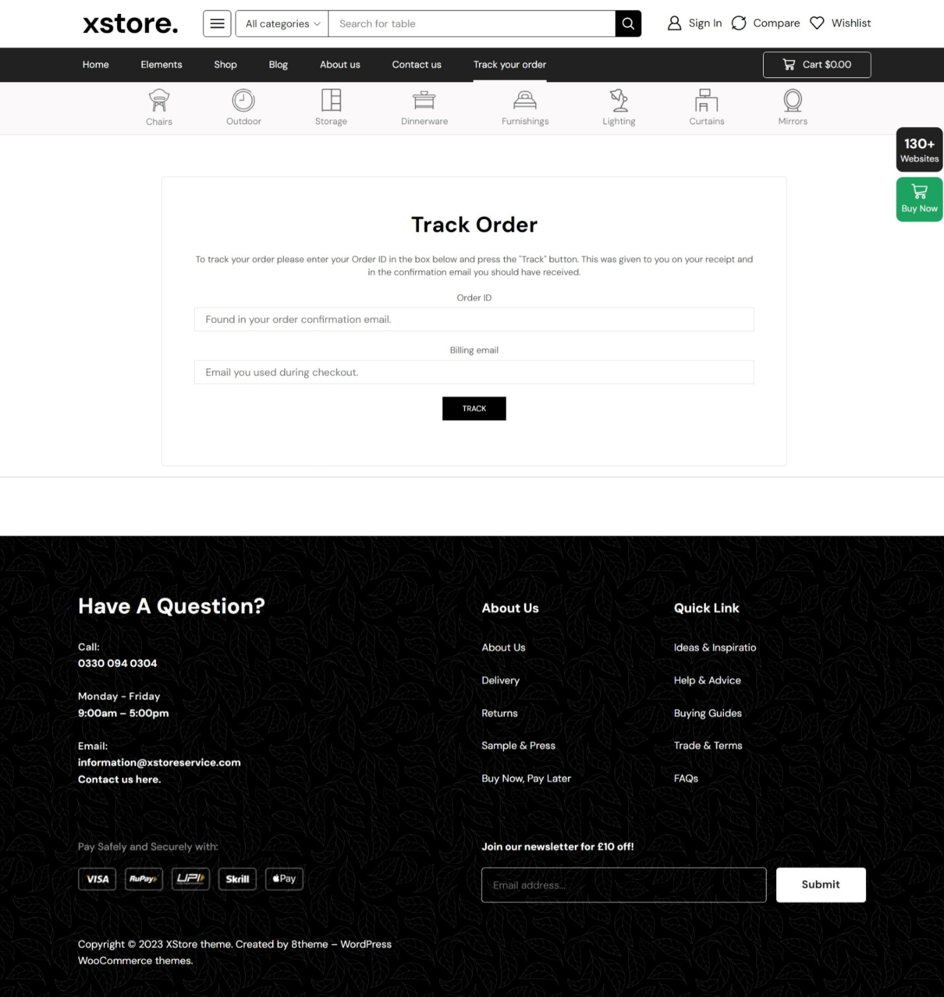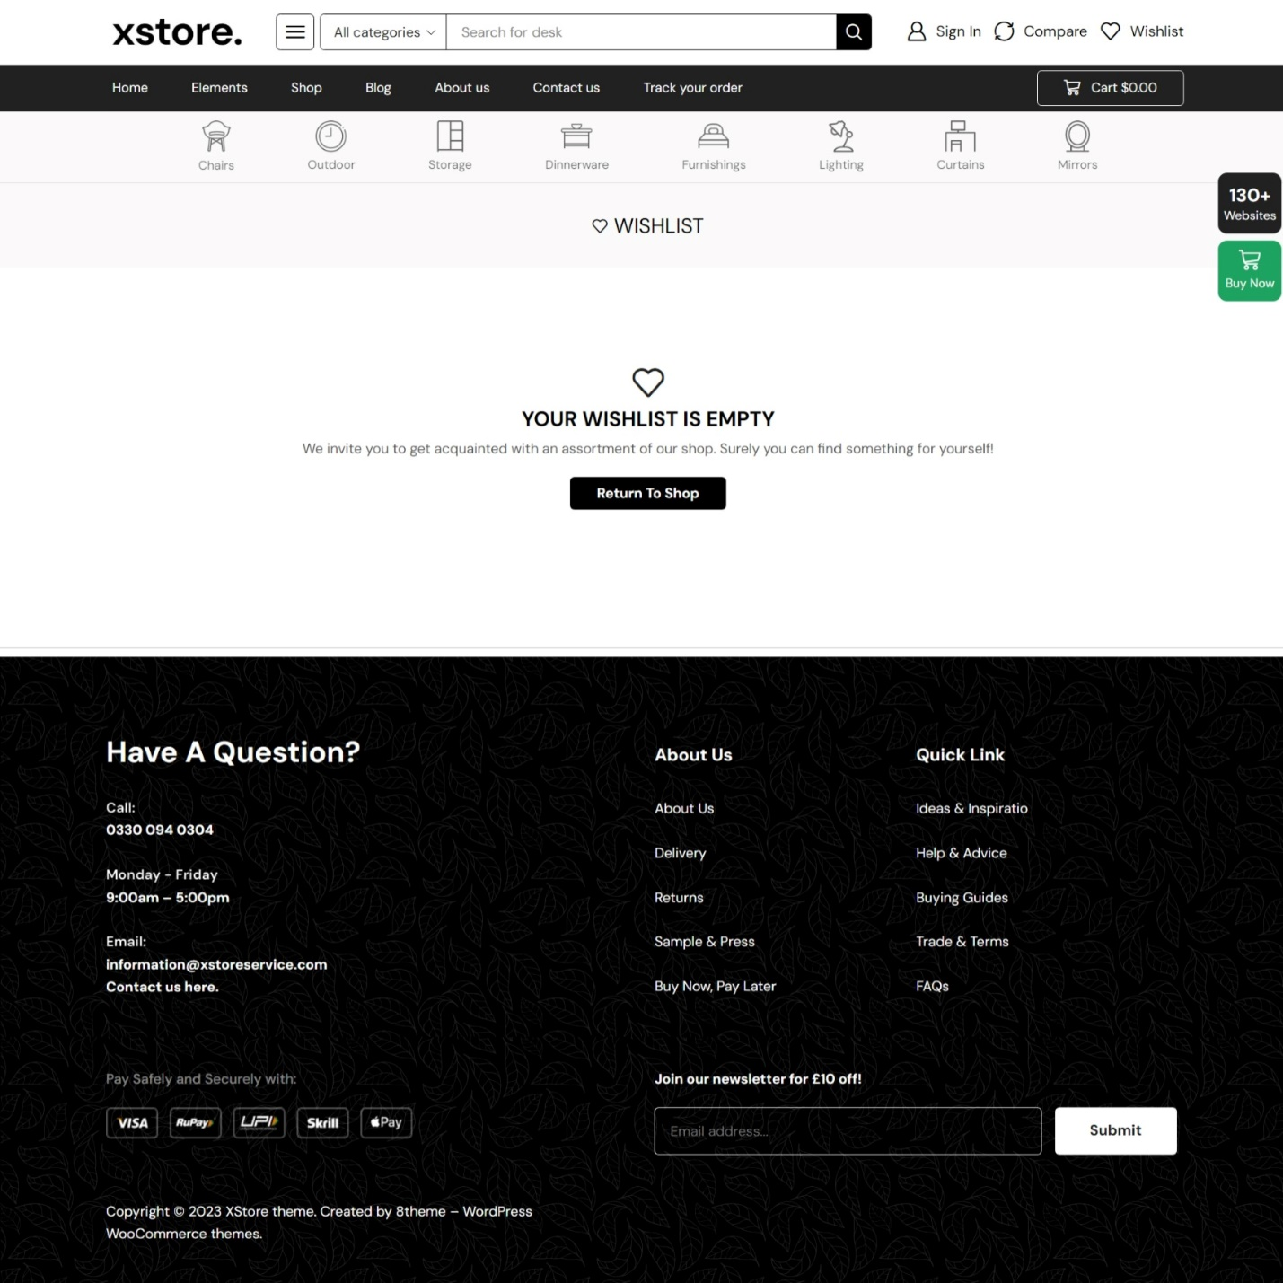

## Appendix I:

* [UML Class Diagram Tutorial (visual-paradigm.com)](https://www.visual-paradigm.com/guide/uml-unified-modeling-language/uml-class-diagram-tutorial/)
* [Class Diagram | Unified Modeling Language (UML) - GeeksforGeeks](https://www.geeksforgeeks.org/unified-modeling-language-uml-class-diagrams/)
* [Entity Relationship Diagrams with draw.io - draw.io (drawio-app.com)](https://drawio-app.com/blog/entity-relationship-diagrams-with-draw-io/)
* [E-Commerce Website UML Diagrams [Complete] | Itsourcecode.com](https://itsourcecode.com/uml/e-commerce-website-uml-diagrams-complete/)